Week1_Day2 TASK
API Request
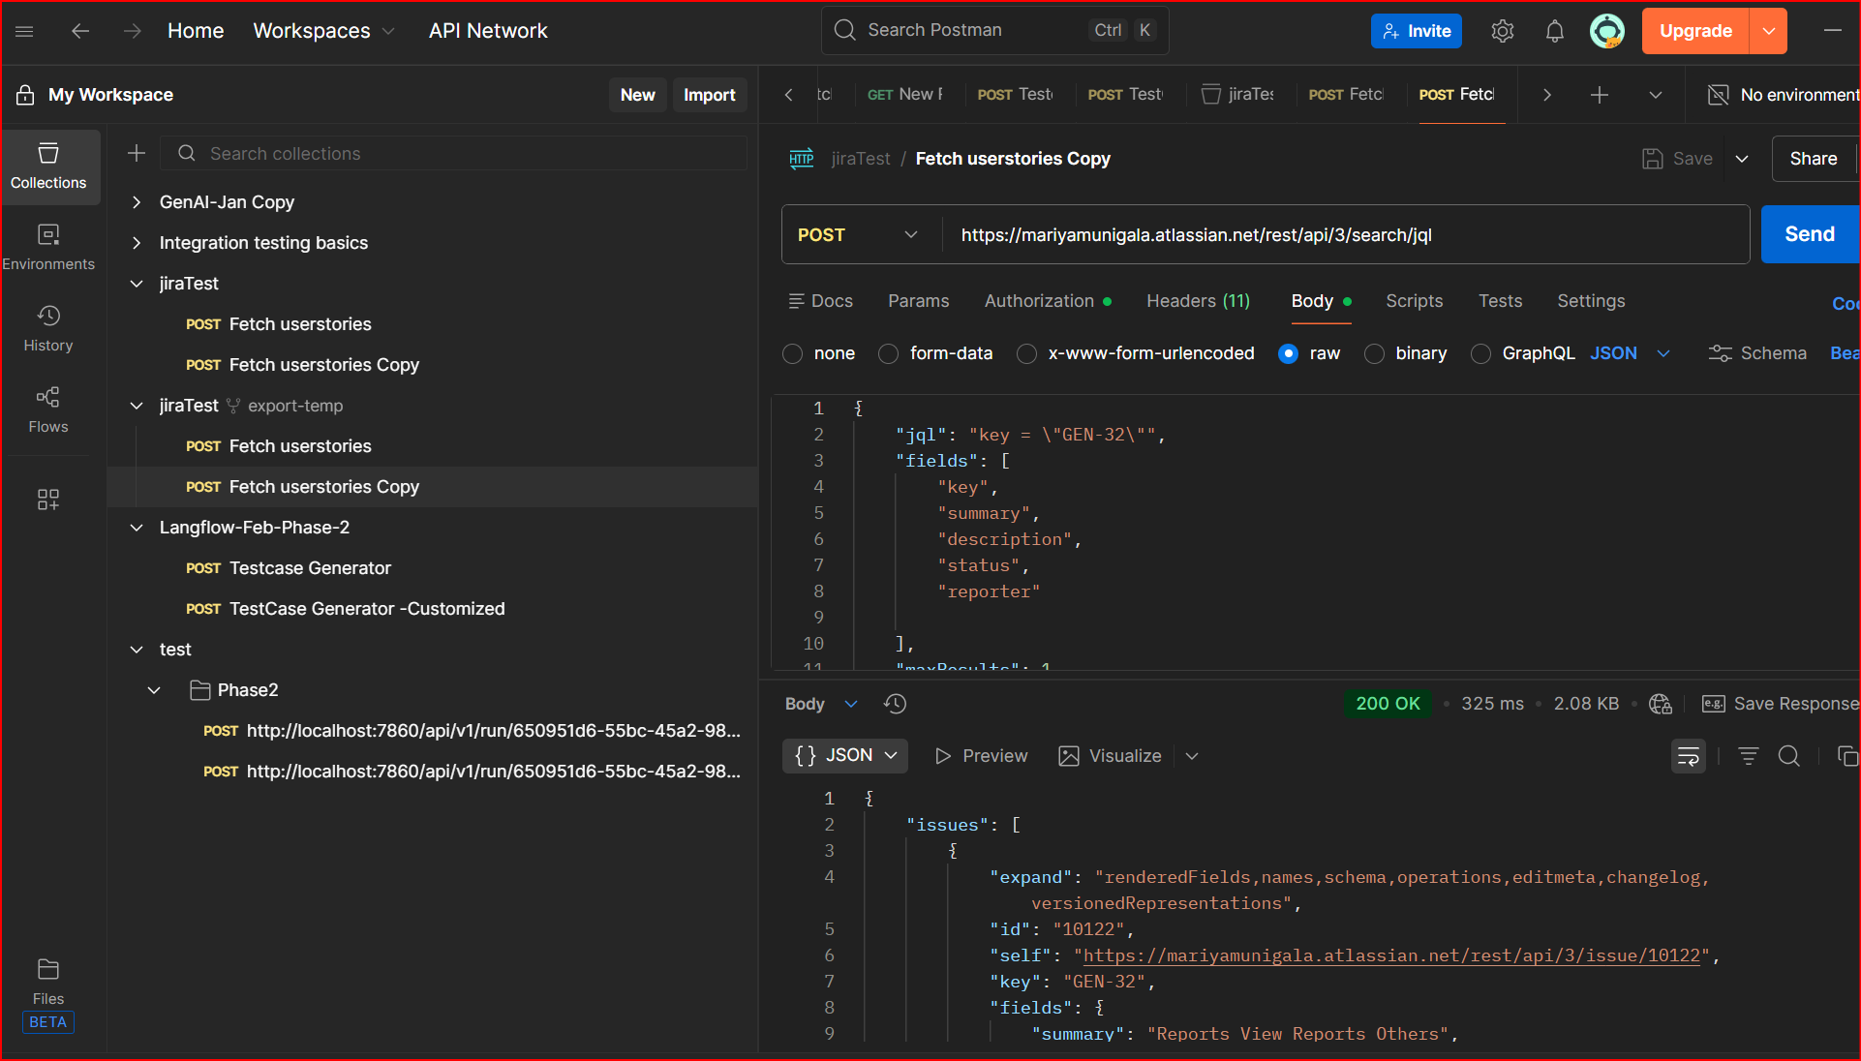

Lang Flow
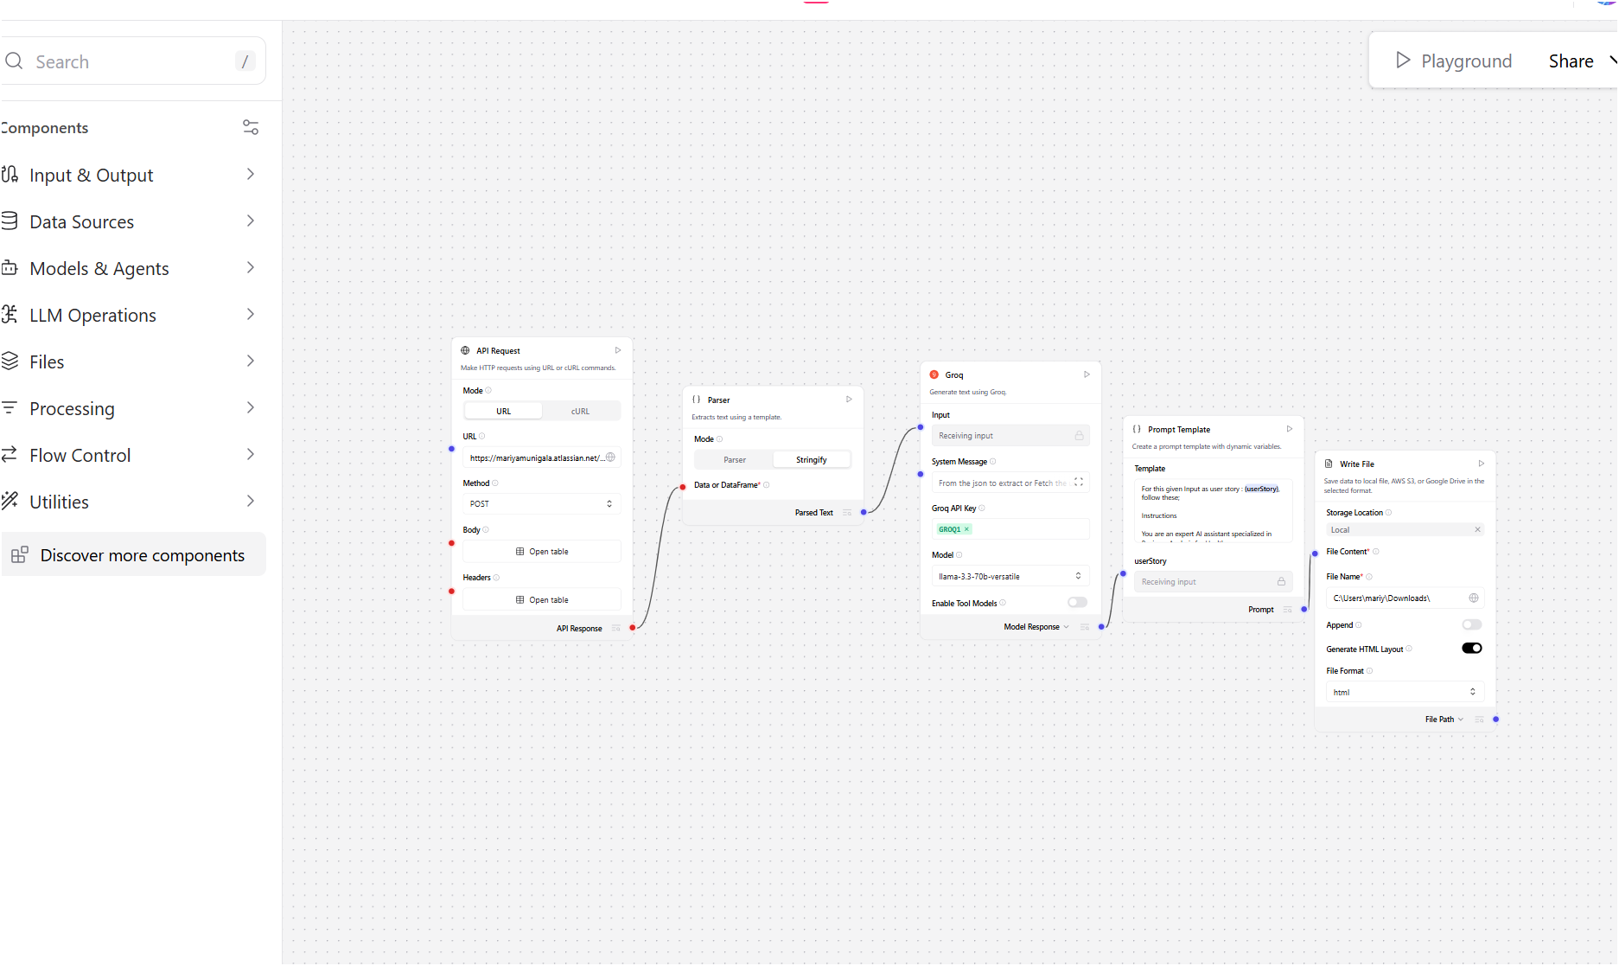

Custom Component HTML User Story Quality Analysis Report
Project: GEN • Issue Key: GEN-32 • Reporter: maria

User Story
Title: Reports View Reports Others
Description: As a user, I want to reports view reports others so that the related functionality works as expected.
Acceptance Criteria: Not provided
Status: In Progress

Quality Assessment
Parameter | Assessment | Score (out of 20)
Clarity | The story title "Reports View Reports Others" is vague and lacks clear intent. The description uses awkward phrasing ("I want to reports view reports others") making it difficult to understand the exact user need. The persona is generic ("As a user") rather than a specific healthcare role (e.g., clinician, administrator, compliance officer). Ambiguous language makes it unclear whether "others" refers to other users' reports, other report types, or a different feature altogether. | 6
Completeness | No acceptance criteria are defined. Preconditions (e.g., user authentication, role-based access, report availability) are absent. There is no mention of data filters, report formats, or access permissions. Edge cases (e.g., no reports available, unauthorized access attempts) are not addressed. Missing definition of "done" makes this story incomplete for sprint planning. | 4
Business Value Alignment | The "so that" clause ("the related functionality works as expected") is a generic placeholder and does not articulate tangible healthcare value. There is no mention of patient safety, clinical decision support, compliance (HIPAA/PoPIA), operational efficiency, or audit requirements. In a healthcare context, report viewing could relate to lab results, discharge summaries, or compliance audits — but none of this is specified. | 5
Testability | Without acceptance criteria, QA engineers cannot derive meaningful test cases. It is unclear what constitutes a "report," what data should be displayed, or what "others" means. No validation rules, expected behaviors, or error scenarios are described. This story is essentially untestable in its current form. | 3
Technical Feasibility | While viewing reports is technically straightforward, the lack of specificity (report types, data sources, access control model, rendering format) makes implementation ambiguous. In a regulated healthcare environment, viewing "others'" reports requires careful role-based access control (RBAC) design and audit logging — none of which is addressed. | 8
Overall Quality Score
26 / 100
Rating: Needs Significant Rework

Improvement Recommendations
- Rewrite the story with a specific persona: Replace "As a user" with a healthcare-specific role, e.g., "As a clinical administrator, I want to view reports submitted by other department staff so that I can monitor compliance and patient care quality."
- Define clear acceptance criteria:
  - User can filter reports by date range, department, and report type.
  - Only reports from users within the same organizational unit are visible (RBAC enforced).
  - An audit log entry is created each time a user views another user's report.
  - Reports display patient data in a de-identified format unless the viewer has explicit authorization.
- Articulate business value: Specify the healthcare outcome — e.g., regulatory compliance monitoring, clinical quality improvement, or operational oversight.
- Add preconditions: User must be authenticated, have the appropriate role/permission, and belong to the relevant organizational unit.
- Specify report details: Define what report types are in scope (lab, radiology, discharge, compliance), what fields are displayed, and what export/download options are available.
- Address compliance requirements: Include HIPAA/PoPIA data access rules, minimum necessary standard, and audit trail requirements for accessing other users' reports in a clinical setting.
- Define error and edge-case scenarios: What happens when no reports exist, when the user lacks permissions, or when a report contains sensitive/restricted data?
Analysis generated on March 23, 2026 • Healthcare BA Review • Source: Jira GEN-32

